1. 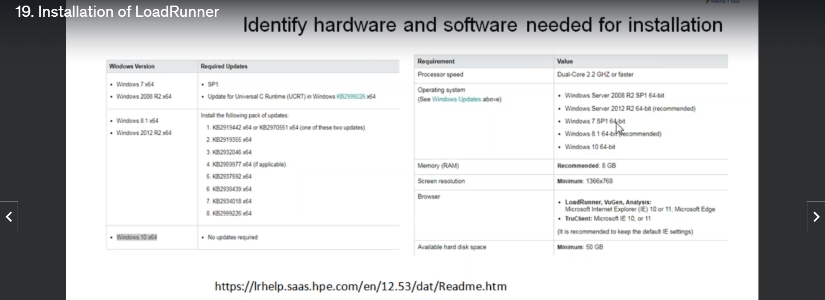
2. Make sure the following three components of LoadRunner are installed.   
   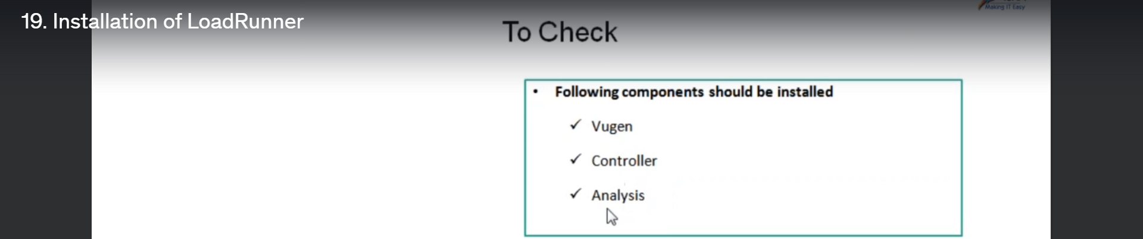  
   How to make sure?  
   Like this 🡪   
   